giLab 2 Screen shots

* Create a local git repository
* Check status
* Add files to this repository
* Check status – screenshot 1

* Add files to stage for tracking
* Check status – screenshot 2

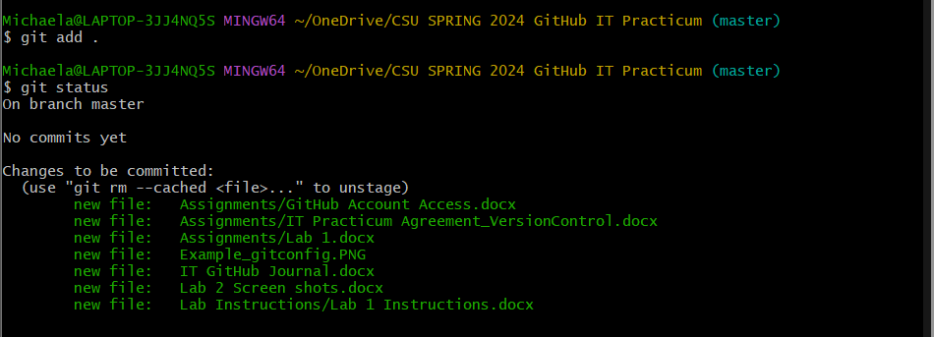

* Make first commit – add REQUIRED commit message
* Check status – screenshot 3

* Edit a file or two
* Check status – screenshot 4

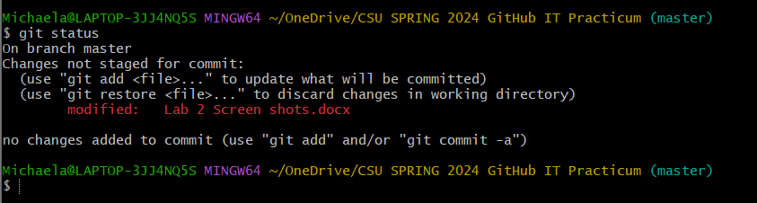

* Add files to stage for tracking
* Check status – screenshot 5

* Make second commit – add REQUIRED commit message